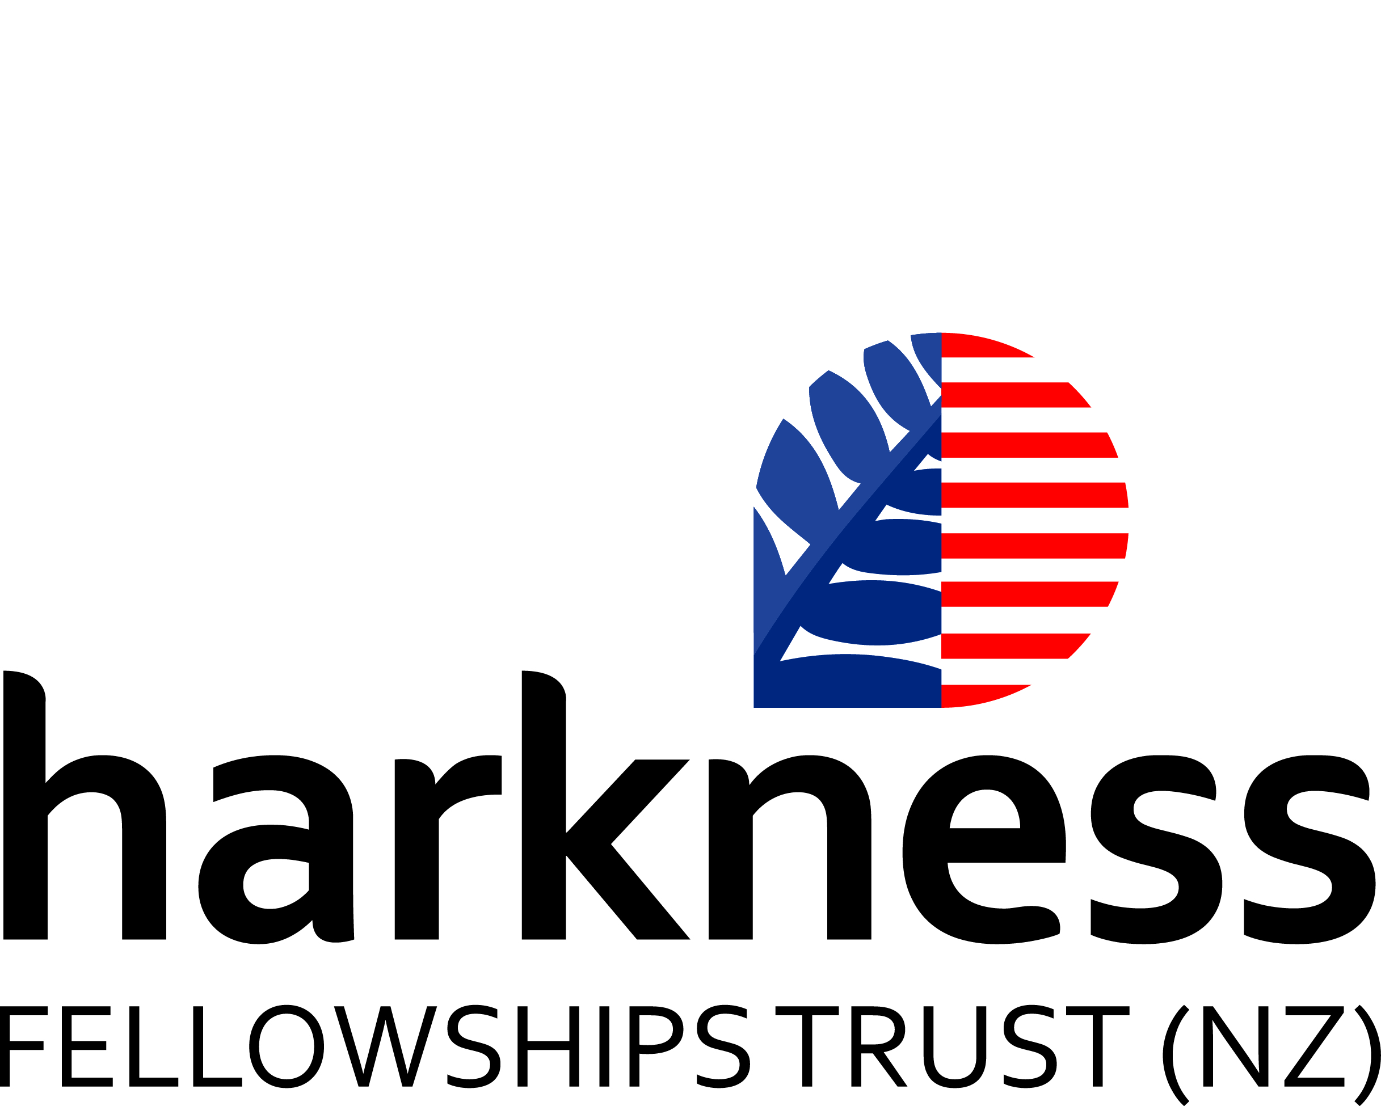

New Zealand Harkness Fellowship

Selection process for 2015

New Zealand Harkness Fellowships are for emerging New Zealand leaders in any field of study or vocation (excluding health care policy and practice) to research what practitioners in the United States have done/are doing in the particular field, distil lessons learnt and explore how they may be applied back in NZ. One New Zealand Harkness Fellowship worth NZ$30,000 will be offered in 2015, to a person who is currently employed in a public sector organisation in New Zealand. The expected study period in the US will be for a minimum of twelve weeks.

The following notes outline the proposed selection process.

Eligibility Requirements and Personal Attributes

To be eligible for the New Zealand Harkness Fellowship, applicants must:

- have a degree or an equivalent qualification conferred by a professional body, and an outstanding record of achievement in their own professional career; and
- be a New Zealand citizen (those holding US citizenship or US residence permits are not eligible) who is currently resident in New Zealand.

The Selection Board will be seeking the following attributes for award of a Fellowship. Applicants will need to:

- demonstrate exceptional personal and intellectual qualities and a strong track record of achievement and leadership;
- outline their ideas for how their experiences in the US will be communicated and applied to the New Zealand context to effect a particular outcome(s);
- demonstrate a track record of learning and growth in characteristics representative of the future leadership that the NZ public sector needs;
- effectively communicate the nature of an inclusive New Zealand culture to an international audience;
- provide evidence of a planned and purposeful approach to the Fellowship.

There is no fixed age limit but preference will be given to early to mid-career New Zealand professionals.

Preference for the Fellowship will be given to candidates who have not had recent experience in the US ( i.e. have not studied, taught, researched or worked in the US for a period aggregating more than nine months/one academic year during the past five years).

Entitlement
One Fellowship valued at NZ$30,000 is offered in 2015. New Zealand Harkness Fellowships are intended to contribute towards travel costs (international and domestic), accommodation and per diem expenses. The funds are not intended for the purchase of equipment or any other research costs. Additional costs in excess of NZ$30,000 must be met by the Fellow and/or their New Zealand employer.

Application process

The application process will be as follows.

An application form is provided separately that sets out detailed information required by the Selection Board as well as that needed for visa purposes.

Applicants must provide the following additional material:

- Curriculum vitae of no more than four pages (2 x double sided pages);
- A short statement about any previous experience in the United States;
- A statement by their organisation about leadership experience and potential (1 page)
- Project Statement ( 1 page);
The proposed project should contribute to the development of knowledge in the respective field. The Project Statement should clearly define the aims of the project, the methodology, and the importance of the project-- for the field, for New Zealand and for the applicant’s own professional development;
- Proposed host institution (1 page):
Applicants should have a letter of invitation from their US host institution or, at least have identified an institution that has appropriate facilities for the project they wish to undertake.
Applicants are asked to submit these documents to Dr Colin Kennedy, the Director of Programmes and Engagement at Fulbright NZ (colin@fulbright.org.nz) in one PDF file rather than multiple word documents.

Applicants must also obtain up to three confidential letters of reference, to be sent directly to Fulbright NZ. Referees should provide a candid confidential assessment of the applicant to the Panel, addressing as many as possible of the following in 1-2 pages:

- the period of time that the referee has known the applicant and in what capacity;
- the applicant’s professional qualifications and accomplishments;
- what the referee would see as their strengths and weaknesses;
- the calibre of the applicant’s work and potential for contribution to their field and proposed study topic;
- any particular qualifications, experiences or reasons why the applicant should be selected to be a New Zealand Harkness Fellow;
- the applicant’s leadership potential;
- the suitability of the candidate’s proposed programme in the US.

The Selection Board may, at its discretion, also wish to talk in person with nominated referees for candidates.

Fulbright NZ will check the above details and indicate to the Selection Board whether any eligibility criteria have not been met.

Depending on the number of initial applications, the Selection Committee will then reduce the number to a short list of no more than four candidates.

Selection

The interviews will be held in Wellington. Fulbright NZ will arrange travel for candidates outside Wellington.

The Selection Board will consist of:

Ross Tanner (chair), Kay Harrison, and Professor Richard Faull from the Harkness Trust Board and one nominee from the Leadership Development Centre.

Timetable

The following timetable is planned:
- Closing date for applications, to be sent to Fulbright New Zealand-- 5.00pm on 14 September 2015.
- Selection Committee shortlisting completed-- 30 September
- Selection meeting and interviews—22 October from 11am to 3pm
- Announcement of the 2015 Fellow – evening 22 October
- Fellow leaves for the US – early to mid- 2016

Ross Tanner
Chairman,
NZ Harkness Fellowships Trust Board

This includes the State Services, tertiary education institutions, State-Owned Enterprises and Crown companies, agencies that operate as part of the Legislative Branch of Government, and local Government

